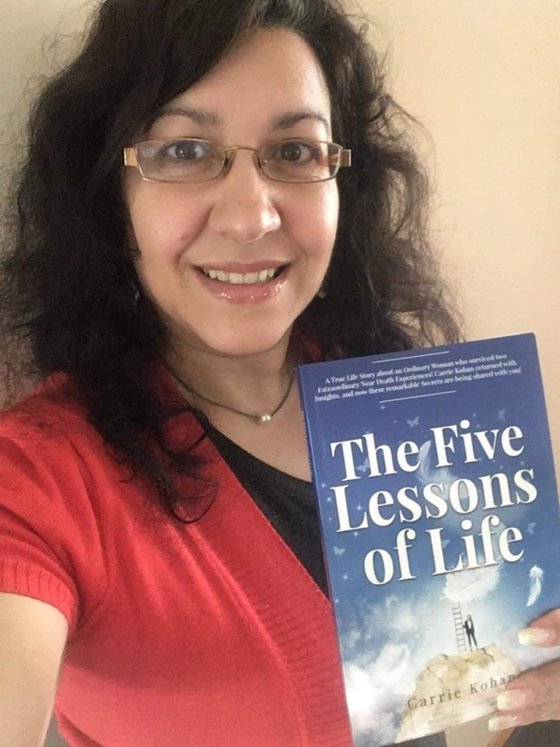
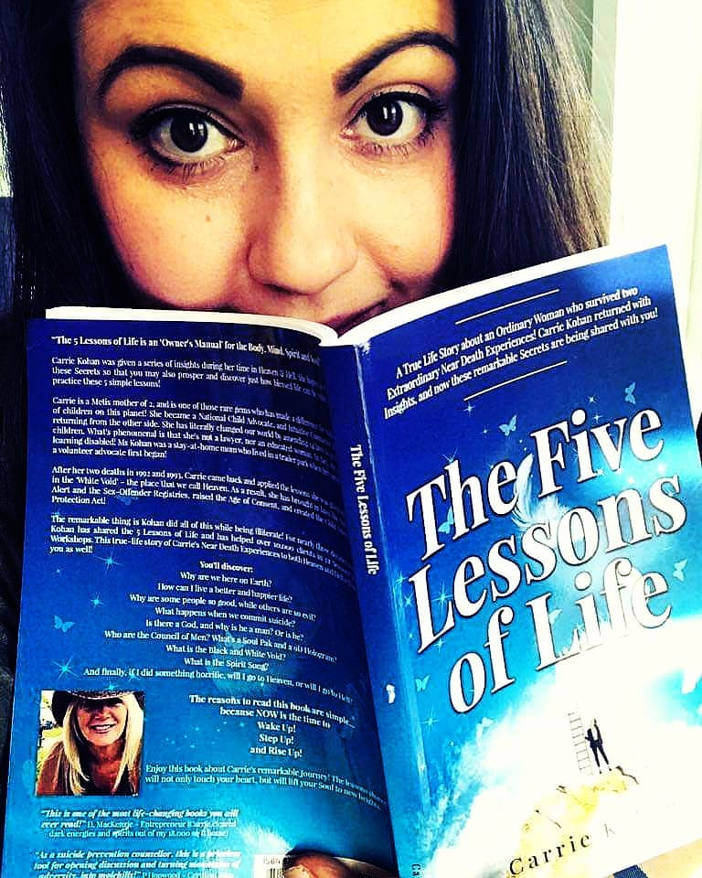
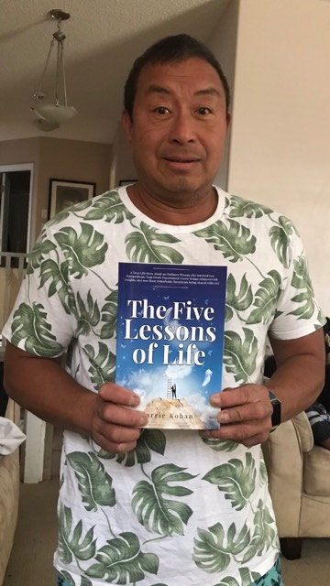
Carrie Kohan’s

‘The Five Lessons of Life’
  - By Carrie Kohan
The 5 Point Formula to Discovering YOUR Life Purpose!

Talent + Interest + Desires + Dreams + Whys = Your Life Purpose!
Example:
- Talent: Painting and Creative Writing, politics, organizing events
- Interest: Working with Handicapped kids – helping them read and learn to paint
- Desires: Change the School System – stop the ‘Wait to Fail’ and have early assessments of each child’s Learning Modalities - VAKS
- Dreams: See a time where schools are 100% supportive of each child’s needs and talents
- Why: My own past pain of being Learning Disabled in school and feeling like a dummy
- Therefore, Your Life Purpose is…
- I AM an Advocate for a new way of introducing children to school! And for the support and education of each child. No more wait to fail and instead early assessments and placements for each child – with emphasis on the arts, creative thought and / or physical activities as well. Create art programs to build self-esteem and creative expressions for both children and adults. An online course as well as something implemented into the regular school systems.

For further information on how to
Discover Your Life Purpose
- Contact Carrie Kohan of Freedom Masters Academy at support@carriekohan.com

- Carrie Kohan is a Canadian National Child Advocate currently living in Canada, Portugal and the UK

- She is an International Best-Selling Author who brought Amber Alert and 13 other laws into Canada to protect children. Carrie is available to work with you in person or via the net as a Speaker, Course Facilitator, Soul Coach, or travel to your location for Talks and book signings.

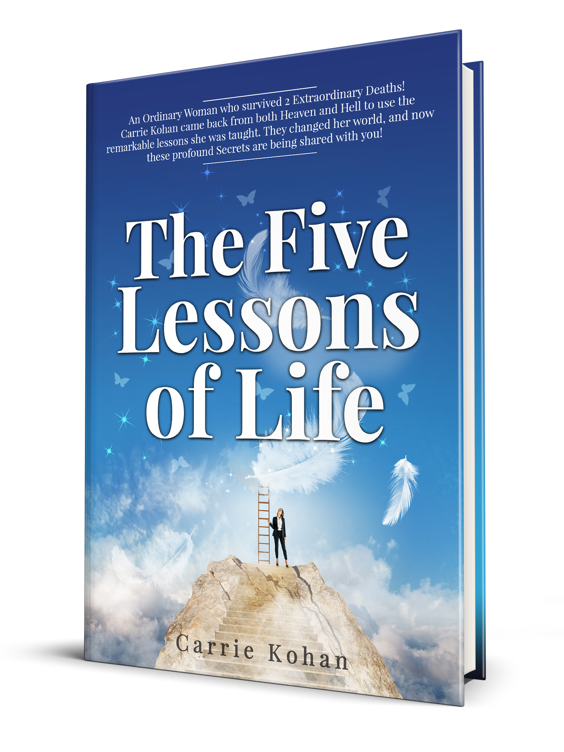
- For World-wide links to purchase ‘The Five Lessons of Life’ go to www.CarrieKohan.com

Please leave feedback on https://www.facebook.com/TheFiveLessonsOfLife/

